Determinants of data science salary

Introduction:
The fast growth of the data and artificial intelligence sectors has ensured that data-related professions have become among the highest paying jobs across the globe. Nevertheless, there is considerable heterogeneity within the salary structure in this sector. The purpose of this paper is to econometrically examine the key drivers behind data scientists’ salaries. The current paper attempts to answer three primary research questions:
(1) Which factors such as experience, job title, company size, and location most significantly influence data science salaries?
(2) Do market dynamics differ in the US compared to non-US markets regarding how experience is rewarded?
(3) How does company size interact with an employee's experience level in determining their financial compensation?
Methodology & Analysis:
(NOTE: All econometric tests and questions throughout this report utilize a 5% significance level).
Data Description (Descriptive and Graphs):
- Data Overview:
The dataset employed in this analysis is obtained from the file ds_salaries.csv and contains 607 cross-sectional observations on the salary of data scientists spanning from 2020 to 2022. The dependent variable of the analysis is salary_in_usd, the standard measure of pay expressed in US dollars for ease of international comparison. Several categorical independent variables have been used to reflect the attributes of both the worker and employer. The categorical independent variables include: experience_level (Entry level, Mid level, Senior level, Executive level), employment_type (full time, part time, contract, freelance), job_title (classified based on functional areas such as Analyst, Engineer, Scientist and Other) remote_ratio (Onsite, Hybrid, Remote), company_location (US or Non-US) and company_size (small, medium, large).

- Exploratory Data Analysis (EDA):
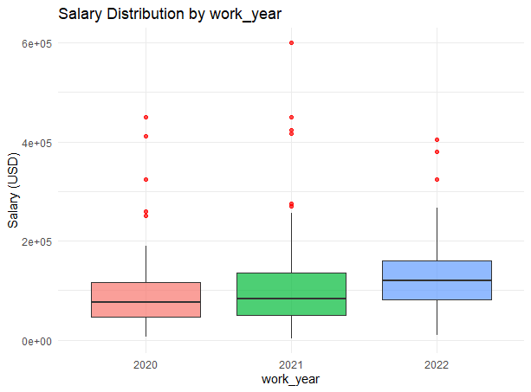
The salaries have increased from 2020 to 2022 as evidenced from the boxplot-the median salary increased consistently throughout the observed years. The general trend in the observed period is that salaries have increased in the data science and data analysis sectors. The variation across the 2022 distribution also seem to increase-indicating greater disparity in wages among employees. Some extreme outliers are also evident throughout all the years and particularly 2021-there are employees with salaries well over $600,000-demonstrating the presence of extremely high paying jobs. The distributions are right-skewed-the lower whiskers are shorter than the upper whiskers-suggesting that some workers earn unusually high salaries as compared to the bulk of the population. Econometrically, the growing variance and outliers suggest heteroskedasticity and potential need for log transformation.
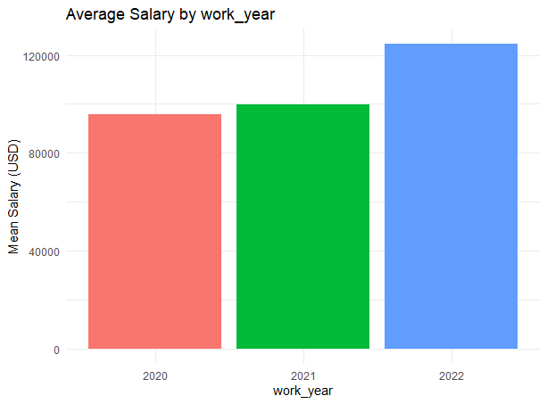

the bar chart displays a steady upward trend of the average salary between 2020 and 2022. Despite the slight rise from 2020 to 2021, there was a significant jump in 2022, where the average is over 120k dollars. Such growth illustrates the excellent growth in salary in the field of data science over time; potentially attributed to the demand of data related positions growing over the time period and an increase in AI & Analytics fields. It also supports the deduction made that there was a rising competitiveness in data related professions during this period.

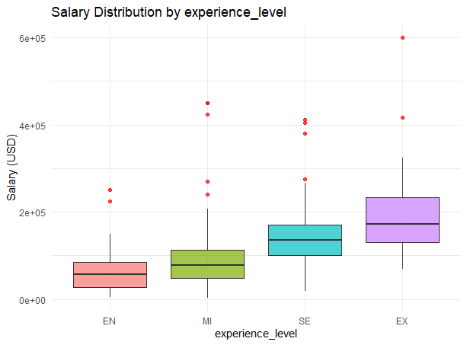
The boxplot confirms the strong positive relationship between experience level and salary. Salary consistently increases across from EN to EX level. Highly experienced employee are paid much higher salary, where there are maximum and minimum salaries for EX level compared to other experiences level and the difference between minimum and maximum salary of EX level is largest, that indicates the higher differences of compensation among senior management members. The extreme values of salary for Senior and Executive level above $600,000 are also identified, as well as the positive skewness that suggests a few professionals are making much higher compensation in the salary distribution range.

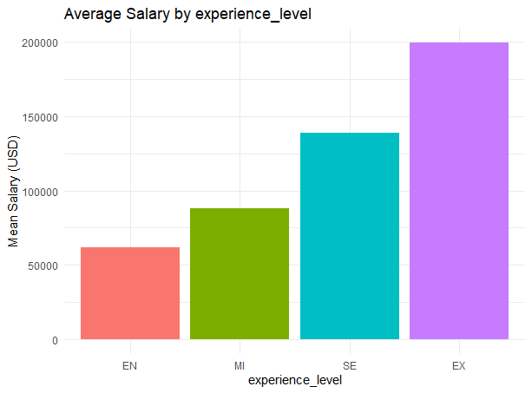
The bar chart reveals an obvious upward trend in mean salaries with increasing levels of experience. Entry-level employee (EN) has the lowest mean salaries and Executive-level employee (EX) has the highest mean salary, at about $200,000. The increment is particularly clear from Mid-level employee (MI) to Senior-level employee (SE), demonstrating the significant effect of working experience on income. The data provides insight to suggest that the level of experience is the most dominant factor impacting on salary in data science.

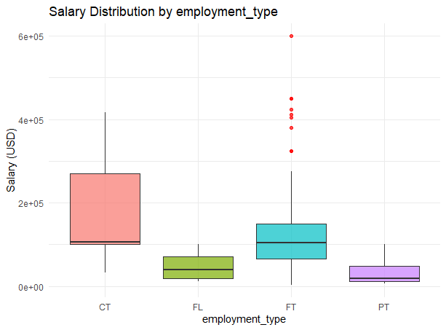
The box plot shows large gaps in the salary distributions for each type of employment. Contract and full-time employment tends to offer the higher compensation values than freelance and part-time employment, respectively. The salary for full-time employment appears to be quite spread out with multiple extreme outliers with salaries that exceed 600,000, indicating the presence of some extremely well-paid positions. The contract and full-time positions also tend to be widely distributed relative to the part-time and freelance jobs. The large gaps among contract and full-time employment shows a high degree of variety in compensation, and the existence of outliers and long upper tails suggests that there are positively skewed salary distributions for each category.

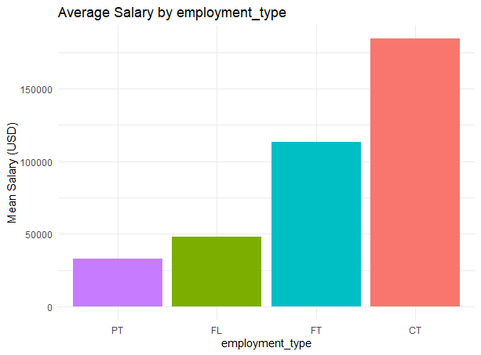
Average salaries vary notably across the different job types in the bar chart. The largest mean is for contract employees (CT), then for full-time employees (FT), and part-time employees (PT) and freelance (FL) jobs have substantially lower mean incomes. This implies that a more secure or specialized type of job relationship has a more advantageous reward, in terms of data science jobs. The range between the highest and lowest mean salary is large, particularly between contract and part-time, implying the type of relationship is a significant variable.

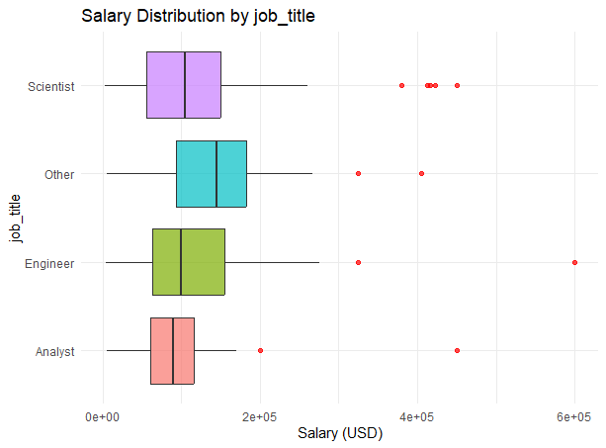
Looking at the boxplot it is clear there are significant differences in salary levels across the various job types. Engineers and Scientists are typically paid a higher salary and also show a higher level of variability in their salary levels when compared to analysts who are paid lower and tend to show higher salary concentration. There appear to be several extreme outliers; particularly Engineers and Scientists have salaries approaching $600,000, pointing to extremely specialized highly paid roles. Many of the job titles appear to positively skewed suggesting a small handful of top earners drag the upper end of the salary distribution up. Clearly job type is a significant factor in determining salary level.
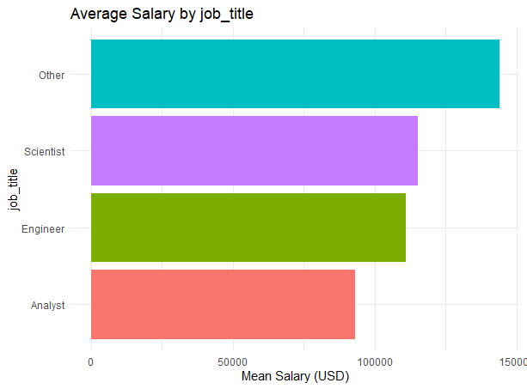
There are a distinct difference in the average salaries for each job title as shown by the bar chart. The analysts have the lowest average salary whereas Engineers and Scientists are highly compensated. The "Other" classification have the highest average salary and could reflect executive roles or specialised roles with a better salary range.

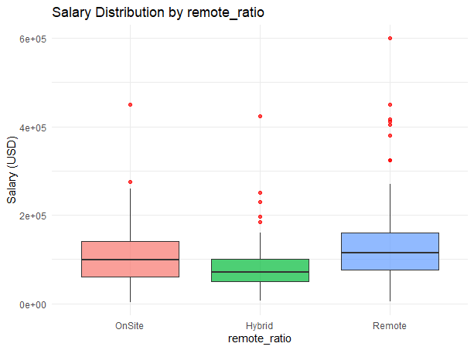
The boxplot shows that the salaries of full-remote workers seem to be higher than those of hybrid workers and onsite workers, since the median salary for remote workers is highest among the three categories. The full-remote jobs also have the widest spread and most outliers in the salaries, where the highest few values reach $600,000. Hybrid workers seem to have the lowest median salary and the narrowest distribution. Positively skewed distribution for all the three categories implies that a few top earners are raising the averages, especially for the full-remote work. It can be interpreted that the data science employees are earning more in the remote job arrangement based on this plot.

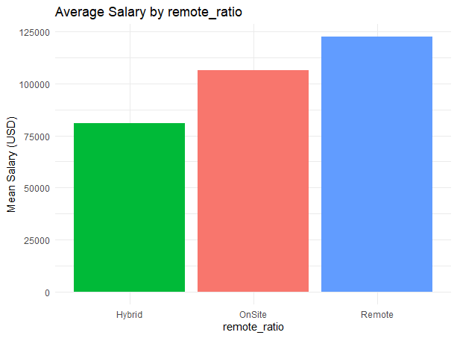
The above chart illustrates that there is a significant disparity between average salaries across different work structures. Fully remote workers make the largest average salary, on-site workers fall second, and workers at hybrid locations have the smallest average salaries. This may be because remote positions in the data science field have the higher average salaries due to possibility of hiring globally, along with the demand for remote workers in the data science sector, and may imply that remote work status can be a large factor in salaries.

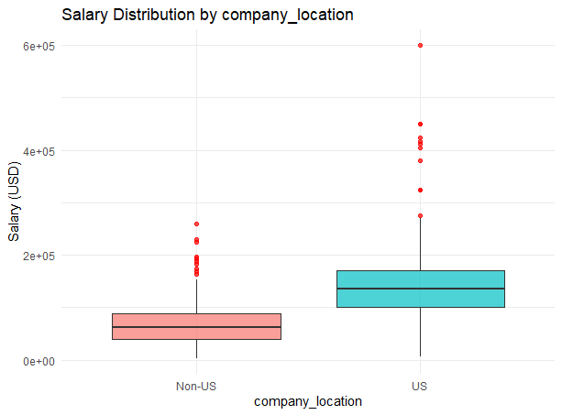

The boxplot clearly shows that the distribution of salaries differ for the US vs non-US companies. Employees that work for US companies have higher salaries. This is suggested by the higher median and wider spread in the boxplot. The US category also includes many outliers (the extremely high ones). The highest values reach as high as 600,000, suggesting there is a demand for high-paid job positions in the US. On the contrary, the non-US companies seem to have lower salaries and also a less spread-out distribution of salaries. Positively skewed distribution of salaries for both categories is suggested and suggests that few very high salaries are pulled towards the right (affecting the median). The effect seems to be more prominent in the US category.
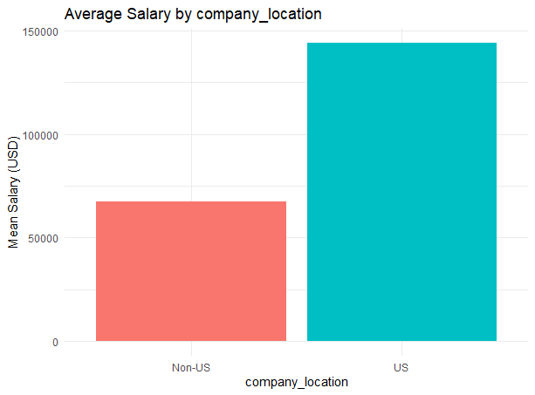
The bar chart shows quite large variation on average salary among US vs non-US companies. The average salary of those who worked in US-based companies are quite much larger than others, where their mean salary is over $140K while those who worked in non-US companies are under $70K. So it can be stated that where the company located could determine the amount of salary they are receiving since the condition in labor market, cost of living as well as how much demand data scientists will vary.

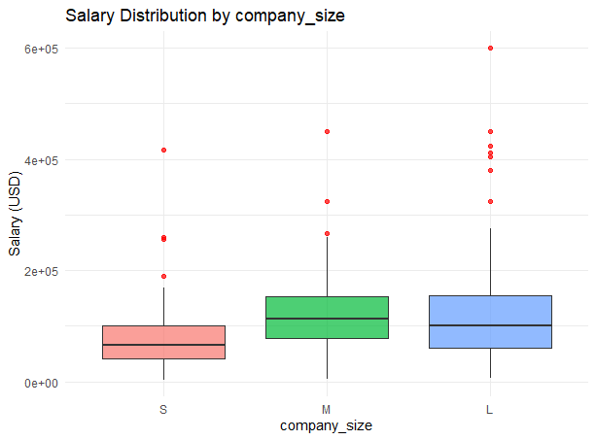
From the boxplot, we can tell that medium and large companies tend to have higher salaries than small companies in the sense that their median salaries are higher. The highest variation is also demonstrated among large companies which also has some extreme outliers with their salaries at $600,000. The range of salaries in small companies seem to have the lower values concentrated with smaller variation. The positively skewed distributions of salaries among company sizes seem to imply that a small amount of very well paid data scientists can significantly impact the upper limit of the salary distribution. It seems like company size has an effect on the level of salaries.
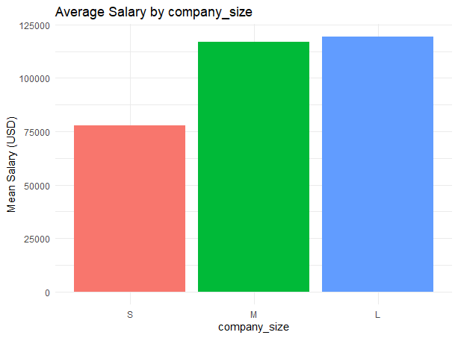
From the bar chart, we see that the average wage is increasing with the size of the company. From S(small), M(medium) and L(large), we see that small companies pay much less than medium and large companies in average. The medium companies pay not much different from the large ones, however, both pays higher than small company much more. This indicates the large companies pay higher on average due to their bigger abilities and competitiveness.
Data Preprocessing & Feature Engineering:
For the purpose of econometric modeling, the first step taken during data preprocessing was the removal of unnecessary variables (such as salary in local currency) and focusing only on salary_in_usd. Due to the high cardinality within the data in job_titles, it was decided to utilize keyword detection techniques and classify all job positions according to their family into one of four categories: "Scientist", "Engineer", "Analyst", or "Other".
Moreover, during preliminary data exploration, it became apparent that the distribution of salaries had a severe positive skew along with extremely high outliers (salaries in excess of $600,000). In order to tackle the issue of outliers and avoid eliminating relevant observations, Winsorization was used. Essentially, this process involves trimming extreme values rather than excluding them from further analysis, maintaining the entire dataset in its completeness. Salaries lower than the 5th percentile were trimmed to this minimum, and those exceeding the 95th percentile were trimmed to the maximum possible value. Categorical variables were properly factorized, using " Entry Level" (EN), "Small Company"(S), Analyst and Non-US as reference levels.
used string detection to categorize all roles into four distinct functional families: "Scientist", "Engineer", "Analyst", and " Entry Level" (EN), "Small Company"(S). Categorical variables were properly factorized, and "Company" (S), and "Analyst" were set as baseline reference levels for the econometric modeling.
Perform suitable econometric models & Test assumptions & Interpret findings:
Q.1) Which Factors Most Influence Data Science Salaries?
- Model 1 — Full Original Model (Raw Salary)
The first model regressed raw salary_in_usd on all six predictors: (experience level, company size, remote ratio, work year, company location, and job title).
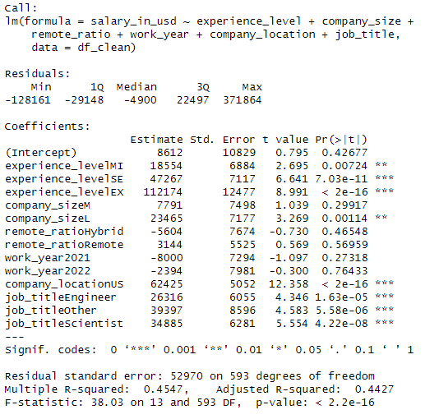
The model explains 45.5% of the variance in salary (Adjusted R² = 0.4427), and is globally significant (F = 38.03, p < 2.2e-16). The most impactful predictors are company location (US premium of ~$62K) and executive level experience (+$112K). Notably, remote ratio, company size Medium, and work year were statistically insignificant in this specification. This model suffers from the presence of extreme outliers. The residuals range from −$128,161 to +$371,864, indicating that a small number of very high salaries are distorting the estimates and inflating standard errors.
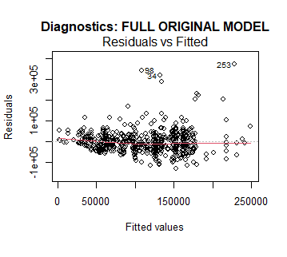
From this plot, we can see that the original model’s residuals flare out and the residuals span from -100000 to +10000, so the residuals are too large, and there is probably heteroscedasticity, which will be further discussed with the assumption testing.
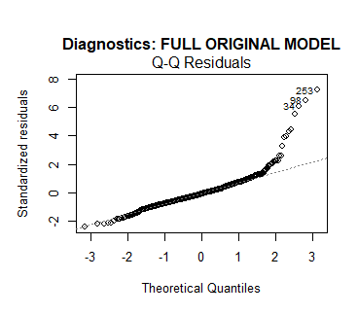
From this plot, we can see that there are outliers at the end of the data that need to be addressed, which we will be addressing in the next model.
- Outlier Treatment — Winsorization (Handling Outliers)
To address the outlier problem without discarding observations, Winsorization was applied. This technique caps extreme values rather than removing them, preserving the full sample size while reducing the influence of outliers. Specifically, salaries below the 5th percentile were capped at that floor, and salaries above the 95th percentile were capped at that ceiling. This means the top and bottom 5% of observations had their salary values replaced by the respective boundary values, keeping the data point in the dataset but preventing it from pulling the regression line.
This approach is preferred over simple deletion because:
- It retains all 607 observations (no loss of statistical power).
- It reduces the residual range substantially — from [−128K, +372K] down to [−126K, +134K].
- It is more honest than deletion since extreme salaries are real, observed values — they just should not dominate the model.
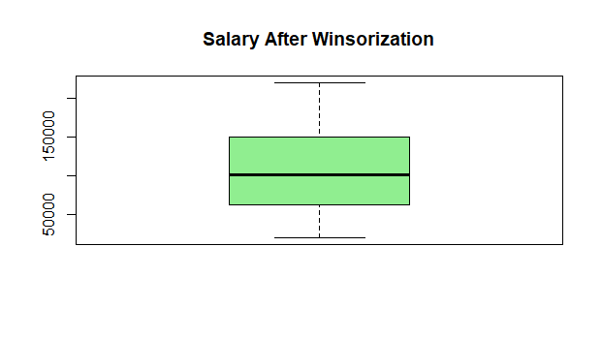
- Model 2 — Winsorized Stepwise Model (Final Selected Model)
After winsorization, a full model was estimated and then backward stepwise selection was applied using AIC as the selection criterion. The stepwise procedure evaluates whether removing each variable improves the model's AIC score, iteratively dropping the least informative predictor until no further improvement is possible. The stepwise procedure dropped remote_ratio from the model, as it contributed no meaningful improvement to AIC. The final selected model is:
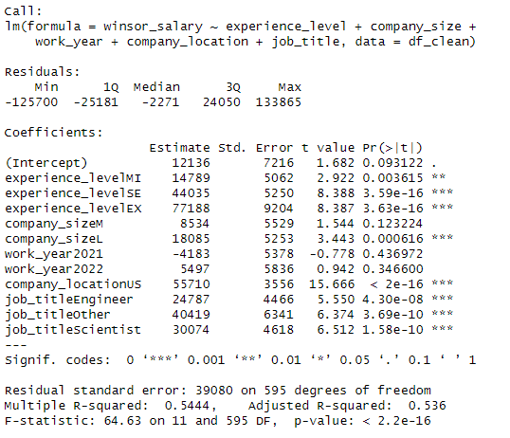
Model Fit:
- Multiple R² = 0.5444 : the model explains 54.4% of the variance in winsorized salary.
- Adjusted R² = 0.536 : a meaningful improvement over Model 1 (44.3%).
- Residual Standard Error = $39,080: reduced from $52,970 in Model 1, confirming better fit after winsorization.
- F-statistic = 64.63, p < 2.2e-16: the model as a whole is highly statistically significant.
Coefficient Interpretation:
- Reference group: Entry-level experience (EN), Small company, Year 2020, Non-US location, Analyst job title.
- Intercept = $12,136: This represents the predicted average salary for an entry-level analyst, at a small non-US company in 2020, working on-site. It is marginally significant (p = 0.093), which makes intuitive sense — entry-level non-US data professionals have a low but positive baseline salary.

- Experience Level is the most consistently significant predictor:
  - Mid-level employees earn on average +$14,789 more than entry-level (p = 0.004).
  - Senior employees earn +$44,035 more (p < 0.001). This is a large and robust effect.
  - Executive-level employees earn +$77,188 more than entry-level (p < 0.001). The salary premium scales steeply with seniority, confirming a strong experience gradient in data science compensation.
- Company Location has the single largest coefficient:
  - Working in a US-based company is associated with a +$55,710 salary premium (p < 2e-16). This is economically enormous — more than $55K just for geography. It reflects both the higher cost of living and the competitive US tech labor market.
- Job Title is highly significant across all categories (relative to Analyst):
  - Engineers earn +$24,787 more (p < 0.001).
  - Scientists earn +$30,074 more (p < 0.001).
  - Other roles earn +$40,419 more (p < 0.001), likely capturing senior management and specialized titles grouped here.
- Company Size shows a partial effect:
  - Large companies pay +$18,085 more than small companies (p < 0.001).
  - Medium companies show +$8,534 but this is not statistically significant (p = 0.12), suggesting the real size divide is between Small and Large.
- Work Year (2021, 2022 vs. 2020 as reference):
  - Neither year dummy is statistically significant (p = 0.44 and p = 0.35 respectively), suggesting no strong time trend in salary over this period after controlling for other factors. Work year was retained by stepwise as it collectively contributed to model AIC despite individual insignificance.
Assumption Testing — Final Model:
- Multicollinearity (VIF):
All Generalized VIF values are well below the standard threshold of 5
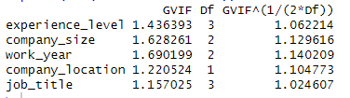
Conclusion: No multicollinearity problem. The predictors are essentially independent of each other, meaning the coefficient estimates are stable and not inflated by inter-predictor correlation.
- Heteroscedasticity — Breusch-Pagan Test:
  - BP = 27.172, df = 11, p-value = 0.0043
The null hypothesis of homoscedasticity is rejected at the 1% significance level. This means the variance of the residuals is not constant across fitted values — higher predicted salaries likely have larger residuals, which is a structural feature of salary data. Winsorization reduced this problem but did not fully eliminate it, because the multiplicative nature of salary (variance grows proportionally with the mean) requires a structural fix .
Impact: The OLS coefficient estimates remain unbiased, but standard errors are incorrect. As a result, t-statistics and p-values should be interpreted with caution. In practice, the very high significance levels (p < 0.001 for key variables) provide a safety margin — the true standard errors would need to be dramatically larger to reverse the conclusions.
- Normality of Residuals — Shapiro-Wilk Test:
  - W = 0.99095, p-value = 0.00089
The null hypothesis of normality is rejected. However, two important caveats apply: first, the Shapiro-Wilk test is extremely sensitive at this sample size (607 observations) even tiny, inconsequential deviations from normality will produce a significant result. Second, with )n > 100(, the Central Limit Theorem ensures that the sampling distribution of the coefficients is approximately normal regardless of the residual distribution, making t-tests and F-tests asymptotically valid. The W statistic of 0.991 is very close to 1.0 (perfect normality), indicating the departure is minor in practice.
- Serial Autocorrelation — Durbin-Watson Test:
  - DW = 1.8672, p-value = 0.0375
The test is marginally significant, suggesting mild positive autocorrelation in the residuals. This result should be interpreted carefully: the Durbin-Watson test is designed for time-series data where observations are ordered in time. In this cross-sectional dataset, the test result depends heavily on the arbitrary row ordering of the data, making it less meaningful. Since this is not a time-series model, no autocorrelation correction is warranted.
Which Factors Most Influence Data Science Salaries?
The three factors that most consistently and significantly drive data science salaries are in order of impact ( where the company is located, how senior the employee is, and what their job title is ). Company size adds a secondary effect, but only at the large-company level. Remote work and time effects are negligible in this dataset.
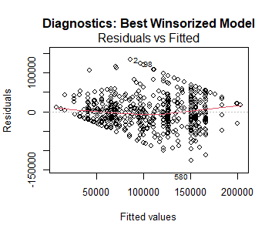
In this plot, we see that the range in residuals increased, ranging from roughly -150000 to 150000. Also, the heteroscedasticity carried on, but with a different shape, so with this, the Winsor model didn’t fix much in this plot.
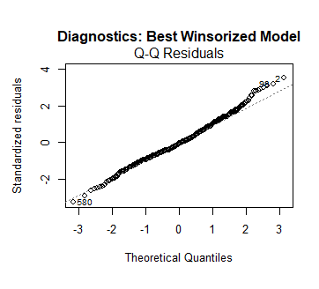
From this Q-Q plot, we can confirm that the winsorization fixed the outliers problem with some point deviating a bit from the line, but it’s within an acceptable range, so in terms of outliers, this is the best model yet.
- Model 3: Log Winsorization
With all the assumptions being violated we tried a final resort by trying to fix some of the assumptions by taking the log of the salary after winsorization.
Final log model after winsorization:
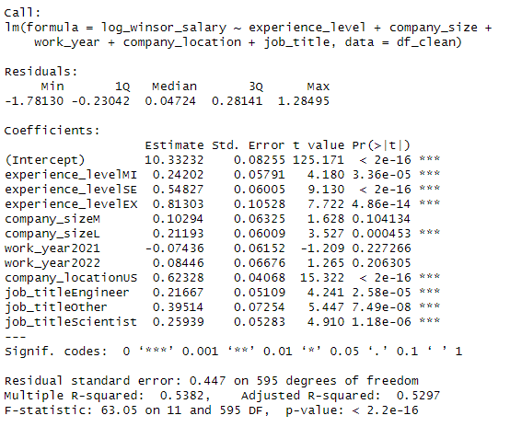
Now this model fixes a problem by making the variation in the residual between -1.78 and 1.28, which is a drastic decrease from the other two models, and the adjusted R2 is great, with it being 0.52. Most of the coefficients are significant with some that aren’t (medium size companies and the years 2021 & 2022).
Assumption Testing For Log Final Model:
- Multicollinearity (VIF test):
There is no Multicollinearity since the test shows all the VIF coefficients are less than 5 shown in the following table:
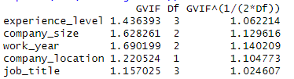
- homoscedasticity (Breusch-Pagan test):
The test assumes that the variance is constant across the residuals (homoscedasticity)(H0)
But the test failed with a P-value of 0.00000034, which is less than α = 0.05.
This means that the residuals have heteroscedasticity, which means that the variance varies in the residuals, which we can also see in the plot of the residuals vs the fitted values.
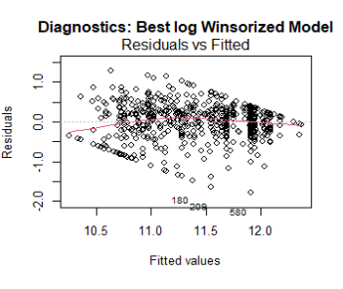
In this plot, the range is finally acceptable, with it ranging from -2 to 1.5, but unfortunately, the heteroscedasticity is still present, taking roughly the same shape as the winsor model, so this can be the better one out of all three.
- normality test (Shapiro-Wilk test):
This test assumes that the residuals are distributed normally (H0)
The test failed as the P-value =4×${10}^{8}$ so this means that the residuals aren’t normally distributed
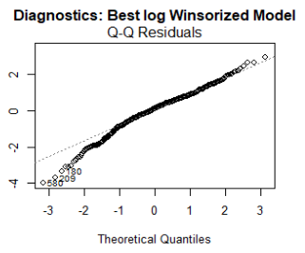
For this model, the Q-Q plot shows that the low numbers have a few outliers, so comparing it to the original, it’s the opposite since outliers were on the far end of the data and it was more deviated too from the line than this, but as for the final comparison, the best model in the Q-Q plot is still the winsor model.
- Autocorrelation test (Durbin_Watson test):
This test assumes that the residuals aren’t correlated with each other and it passes with
P-value = 0.089 so the residuals aren’t correlated with one another.

Why did we choose this model:
Since the log model passed 2 assumption tests, this gives it an advantage, and with the least amount of variation in residuals, with only the residuals varying between -1.7 and 1.2 compared to numbers in the 100s of thousands in the other models so we choose the log model for its advantage in this
Model:
log_winsor_salary = 10.33 + 0.24(MI) + 0.55(SE) + 0.81(EX) + 0.10(M) + 0.21(L) - 0.07(Year2021) + 0.08(Year2022) + 0.62(US) + 0.22(Engineer) + 0.40(Other) + 0.26(Scientist)
Interpretation:
- Experience level:
  - MI: This is a mid-level expert in the field that he works in, and the change that happens when you go from the base entry level, your log of salary will increase by 24%, holding the other variables constant
  - SE: senior, the people that has senior level experience has a 54% increase in their salary log from being entry when the other variables are constant
  - EX: Expert, the people that has an expert level experience have 81% increase in their salary log from being entry level when the other variables are constant
- Company size:
  - L: large companies have a 21% increase in the log of salary that they give from the small size ones, holding the other variables constant
  - M: medium, this is not significant, so this mean by changing the company size from small to medium, there is no significant change in the log of salary, holding the other variables constant
- Work year: This variable isn’t significant in the model, but it increases the overall model R2, which is why it was kept in the stepwise selection
- Location: US, the change from the company location being in the US, other than being outside of it, has a drastic change by increasing the log of the salary by 62%, with the other variables being constant, and this might mean that the US companies may have policies of increasing paychecks for this margin of the data field
- Job Title:
  - Engineer: for being an engineer, the log of the salary will be 22% more than if the person was an analyst with the other variables constant
  - Scientist: if the person was a data scientist, the log of the salary would be 26% more than being an analyst with the other variables being constent
  - Other: for being in another type of data-related job like management or BI, the increase would be 39% in the logged salary, holding the other variables constant
Most impactful:
The change in being an expert from being an entry level is the greatest change, with 80% increase, and then the change from the company being located in the US instead of outside of it, with the increase being 60%, so with this, we will study the interaction between them

Q.2) Do Market Dynamics Differ in the US vs. Non-US?
​Model 4 — Log-Winsorized Interaction Model (Location vs. Experience)
To answer this question and test if the financial return on experience is amplified or altered inside the US compared to the rest of the world, we took the best log-winsorized model and added an interaction term between experience level and company location (experience_level * company_location).
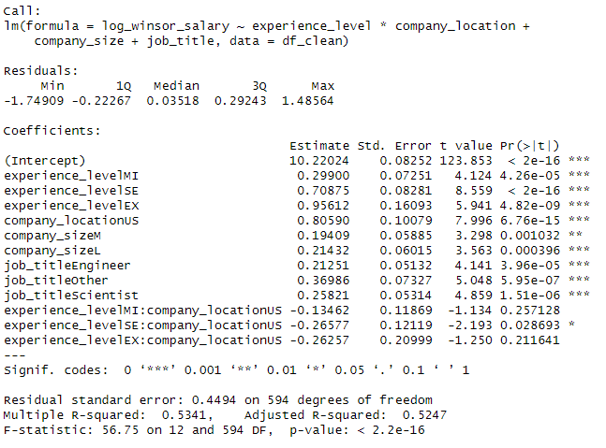

​Now this model fixes the residual variation similar to the previous log model, with residuals ranging tightly between -1.74 and 1.48. The model maintains a strong explanatory power and is highly significant as a whole.
​Model Fit:
- ​Multiple R² = 0.5341 — the model explains 53.4% of the variance in the log of winsorized salary.
- ​Adjusted R² = 0.5247 — after penalizing for the number of predictors, the model demonstrates high stability, showing no drastic change from our best stepwise specification.
- ​Residual Standard Error = 0.4494 on 594 degrees of freedom, confirming a substantial reduction in error variation compared to the raw salary models.
- ​F-statistic = 56.75 (p-value: < 2.2e-16) — the model is globally and highly statistically significant at the 5% level.
​Coefficient Interpretation & Market Dynamics Findings:
- The reference group here is Entry-level experience (EN) in a non-US location, working as an Analyst in a small company.
- ​Main Effects (Baseline Trends): The main effect for location company_locationUS is massive and highly significant (Estimate = 0.80590, p < 2e-16), indicating a huge baseline wage premium for working in the US even at the entry level. The main effects for seniority within non-US companies are also positive and highly significant, showing steady career progression: Mid-level (MI) increases log salary by 0.299 (p < 0.001), Senior (SE) increases it by 0.708 (p < 0.001), and Executive (EX) increases it by 0.956 (p < 0.001).
- ​Interaction Effects (The Core Question): The interaction terms (indicated by the : symbol) reveal whether the financial reward for gaining experience changes when working in a US company.
- experience_level:company_location:
  - experience_levelMI:company_locationUS: This term is statistically insignificant (p = 0.257). This means that the percentage salary jump from entry-level to mid-level does not significantly differ between the US and non-US markets.
  - experience_levelEX:company_locationUS: This term is also statistically insignificant (p = 0.211), showing that the relative reward for reaching the executive level is structurally identical across both geographic regions.
  - experience_levelSE:company_locationUS: This is the only interaction term that shows statistical significance (Estimate = -0.26577, p = 0.028). The negative coefficient suggests that while senior salaries in the US are higher in absolute terms, the specific relative "bonus" jump from entry to senior is slightly compressed inside the US compared to the steeper relative jump observed outside of it.
​Conclusion on Market Dynamics:
The lack of statistical significance across most interaction terms proves that the data science profession maintains a globally consistent reward structure for seniority. Gaining experience gives you roughly the same relative percentage bump whether you are in the US or not; the US market simply starts at a much higher baseline pay grade.
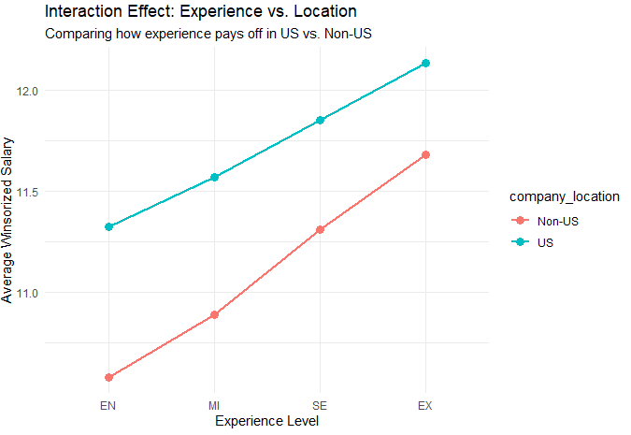
​From this plot, we can visually confirm this structural similarity. The two lines representing the US and Non-US salary trajectories are mostly parallel. The US line sits substantially higher across all experience levels, demonstrating the massive location premium, but the nearly identical slopes indicate that the underlying dynamics of career progression pay off similarly across both markets.
​Assumption Testing —Q2 Interaction Model
- Multicollinearity (VIF test):
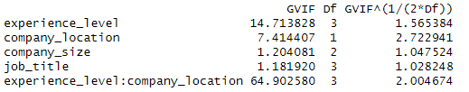
The test notes that there are higher-order terms in the model. While the interaction term experience_level:company_location naturally exhibits an inflated VIF of 64.90 (which is mathematically expected by design in interaction models), the core independent variables like job_title (1.18) and company_size (1.20) remain exceptionally low and close to 1. Conclusion: No severe multicollinearity is harming the stable estimation of our main predictors.
- ​Homoscedasticity (Breusch-Pagan test):
  - Results: BP = 42.503, df = 12, p-value = 2.74e-05
The test assumes that the variance is constant across the residuals (homoscedasticity) (H0). But the test failed with a P-value of 2.74e-05, which is less than α = 0.05. This means that the residuals have heteroscedasticity, taking a similar structural shape as our previous specifications, which is typical for wage data.
- Normality test (Shapiro-Wilk test):
  - Results: W = 0.96895, p-value = 4.884e-10
This test assumes that the residuals are distributed normally (H0). The test failed as the P-value = 4.884e-10, meaning the residuals aren't perfectly normally distributed. However, the W statistic of 0.96895 is very close to 1.0, and since our sample size is large (n = 607 > 100), the Central Limit Theorem ensures that the sampling distribution of the coefficients is approximately normal, making our t-tests and F-tests asymptotically valid.
- ​Autocorrelation test (Durbin-Watson test):
  - Results: DW = 1.8746, p-value = 0.05111
This test assumes that the residuals are not correlated with each other (H0). The test passes successfully with a P-value = 0.05111, which is greater than α = 0.05, confirming that the residuals are independent and free from significant serial correlation.

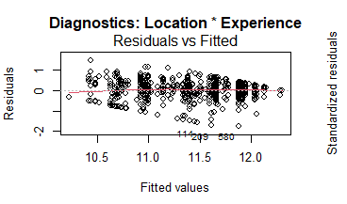
At this plot the points are scattered around the horizontal zero line without a distinct non-linear pattern, which is a good sign for linearity. However, we can observe a slight funnel shape (fanning out), which visually confirms the presence of heteroscedasticity that was detected earlier by the Breusch-Pagan test.
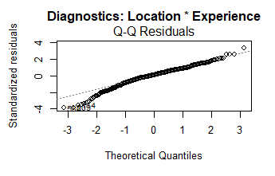
At this plot the majority of the residuals align well with the reference diagonal line, indicating that they are largely normally distributed. There is some visible deviation at the lower tail, which explains the failed Shapiro-Wilk test. However, since most of the data points fall on the line, the departure from normality is not severe in practice.

Q.3) Interaction between Company Size and Experience Level
To test whether the financial reward for seniority varies by company size, we estimated an interaction model between experience level and company size, while controlling for job title and company location.

Model Results
The model has an adjusted R² = 0.5338 and is globally significant (F = 47.26, p < 2.2e-16), meaning the predictors together explain about 53% of the variation in log salary.

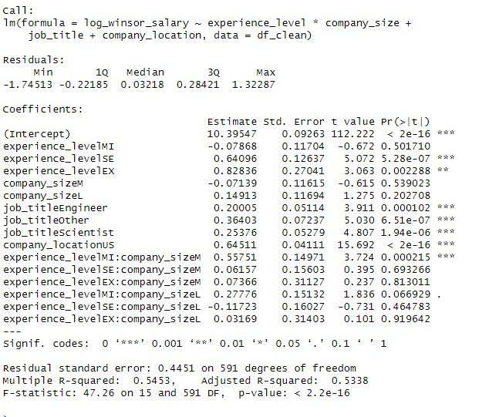
Signif. codes: 0 '***' 0.001 '**' 0.01 '*' 0.05 '.' 0.1 ' ' 1
Residual standard error: 0.4451 on 591 degrees of freedom
- Multiple R²: 0.5453 | Adjusted R²: 0.5338
- F-statistic: 47.26 on 15 and 591 DF, p-value: < 2.2e-16

Interpretation of the Interaction Terms
The reference group here is entry-level (EN) employees in small companies. The main effects tell us the salary difference for seniority within small companies, and the interaction terms tell us whether that difference changes in medium or large companies.

- Main effects — seniority in small companies:
  - SE is significant (p < 0.001): senior employees in small companies earn about 64% more in log salary than entry-level in the same small companies.
  - EX is also significant (p = 0.002): executives earn about 83% more in log salary than entry-level.
  - MI is not significant on its own (p = 0.50), meaning mid-level employees in small companies don't earn significantly more than entry-level ones.

- Interaction terms — does company size change the seniority premium?
  - MI × M (p = 0.0002, ***): This is the only significant interaction. Mid-level employees in medium companies earn an additional 56% in log salary compared to mid-level employees in small companies. This is a large and significant effect.
  - MI × L (p = 0.067, .): Marginally significant. Mid-level employees in large companies earn about 28% more than mid-level in small companies, but this just misses the 5% threshold.
  - All other interaction terms (SE × M, SE × L, EX × M, EX × L) are not significant, meaning for senior and executive employees the salary premium does not significantly differ across company sizes.

So the answer to the question is: seniority does not pay off more in large vs. small companies in general — the only exception is mid-level employees, who earn significantly more in medium companies.

Interaction Plot
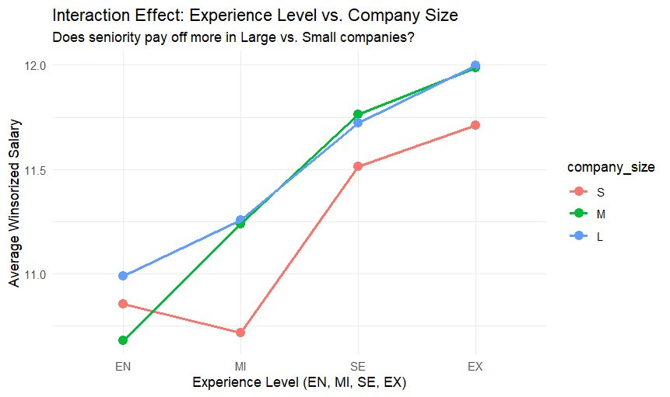
Figure 1 — Average log-winsorized salary by experience level and company size
The plot shows that all three company sizes follow the same upward trend from EN to EX, which matches the fact that the main seniority effect is real. The most visible divergence is at the MI level, where the medium company line (green) jumps up sharply — this matches the significant MI × M interaction term. By the time we reach SE and EX, the three lines come back together, which is consistent with the non-significant interactions at those levels.

Assumption Testing — Q3 Model (Size × Experience)
1- Multicollinearity (VIF test)
There is no multicollinearity since all the adjusted GVIF values are below the threshold. Note that with interaction terms the raw GVIF values are inflated by design, so we look at GVIF^(1/(2×Df)) instead:

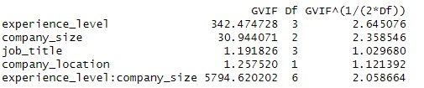
All adjusted values are below 3, so there is no multicollinearity problem.

2- Homoscedasticity (Breusch-Pagan test)
- The test assumes that the variance is constant across the residuals (H0).
  - BP = 40.735, df = 15, p-value = 0.0003509
The test failed — the p-value is less than α = 0.05, so we reject H0. This means the residuals have heteroscedasticity, the variance is not constant. This is a known issue with salary data and is also visible in the residuals vs. fitted plot. The OLS estimates are still unbiased, but the standard errors are not reliable, so p-values should be read with some caution.

3- Normality (Shapiro-Wilk test)
The test assumes the residuals are normally distributed (H0).
- W = 0.97305, p-value = 3.962e-09
The test failed. However, the W statistic is 0.973 which is very close to 1 (perfect normality), so the departure from normality is not severe in practice. Also with n = 607, the Central Limit Theorem means the coefficient estimates are still approximately normally distributed, so the t-tests and F-tests are still valid.

4- Autocorrelation (Durbin-Watson test)
The test assumes the residuals are not correlated with each other (H0).
- DW = 1.8989, p-value = 0.09042
The test passes — p-value = 0.09 > 0.05, so we do not reject H0 and the residuals are not significantly correlated with one another. Same note as before: this test is designed for time-series data so in a cross-sectional dataset like this the result depends on row ordering, but the passing result is still reassuring.

5- Visual Diagnostics
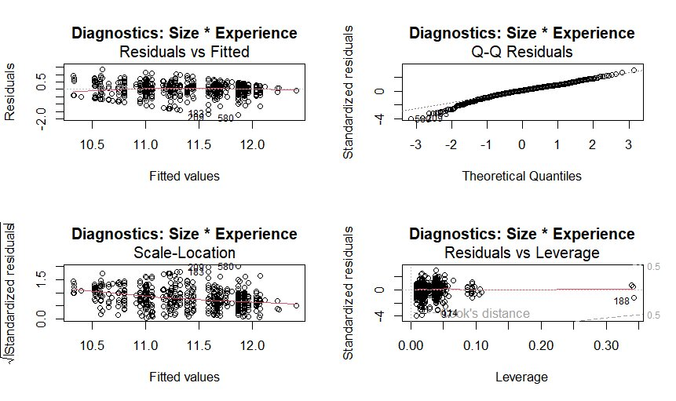
Figure 2 — Diagnostic plots for the Size × Experience model
Residuals vs Fitted: The points scatter around zero with no obvious pattern, which is good. There is a slight fanning out at higher fitted values which is consistent with the heteroscedasticity flagged by the BP test.

Q-Q Residuals: Most points follow the diagonal line well. There is some deviation in the tails, which explains the Shapiro-Wilk failure, but the W = 0.973 confirms this is a minor departure.

Scale-Location: The red line is mostly flat, so the spread of residuals does not change dramatically across the fitted range.

Residuals vs Leverage: Observation 188 has high leverage but stays within Cook's distance bounds, so it is not a problematic influential point.
Conclusion
​In summary, this study analyzed the main factors driving compensation in the data science industry. We found that a professional's salary is mostly determined by their level of experience, the geographic location of their company, and their specific job title. Getting a senior or executive role, working for a US-based company, and taking on a Data Engineer or Scientist position (rather than an Analyst) lead to the biggest salary jumps. Interestingly, the research showed that the "rules of the game" are quite global; while US companies pay significantly more overall, the percentage pay increase an employee receives for becoming a senior expert is remarkably similar whether they work inside or outside the US. Additionally, seniority pays off similarly across both small and large companies, with the only notable exception being mid-level employees, who tend to see a unique salary boost in medium-sized companies.
​References
​Data Science Salaries Dataset (2020-2022).
https://www.kaggle.com/datasets/ruchi798/data-science-job-salaries

Appendices
etermine# ==============================================================================
> # FULL PROJECT SCRIPT: EDA, WINSORIZATION, & STEPWISE MODELING
> # ==============================================================================
>
> # ------------------------------------------------------------------------------
> # 1. SETUP & LIBRARIES
> # ------------------------------------------------------------------------------
> library(dplyr)
> library(ggplot2)
> library(lmtest)
> library(car)
> library(stringr)
>
>
> # Read the dataset
> print("Please select the 'ds_salaries.csv' file...")
[1] "Please select the 'ds_salaries.csv' file..."
> df <- read.csv(file.choose())
>
> # ------------------------------------------------------------------------------
> # 2. DATA PRE-PROCESSING & CLEANING
> # ------------------------------------------------------------------------------
> print("Starting data preprocessing...")
[1] "Starting data preprocessing..."
>
> df_clean <- df %>% select(-1, -salary, -salary_currency)
>
> # Factors Transformation
> df_clean$experience_level <- factor(df_clean$experience_level, levels = c("EN", "MI", "SE", "EX"))
> df_clean$company_size <- factor(df_clean$company_size, levels = c("S", "M", "L"))
> df_clean$remote_ratio <- factor(df_clean$remote_ratio, levels = c(0, 50, 100), labels = c("OnSite", "Hybrid", "Remote"))
> df_clean$work_year <- as.factor(df_clean$work_year)
> df_clean$employment_type <- as.factor(df_clean$employment_type)
>
> # Simplify Location and Job Titles
> df_clean$company_location <- as.factor(ifelse(df_clean$company_location == "US", "US", "Non-US"))
> # ------------------------------------------------------------------------------
> # UPDATED: Advanced Job Title Categorization using Pattern Matching
> # ------------------------------------------------------------------------------
> # Simplify job titles into four main functional categories
> df_clean <- df_clean %>%
+ mutate(job_title = case_when(
+ str_detect(tolower(job_title), "scientist") ~ "Scientist",
+ str_detect(tolower(job_title), "engineer") ~ "Engineer",
+ str_detect(tolower(job_title), "analyst") ~ "Analyst",
+ TRUE ~ "Other"
+ )) %>%
+ # Convert the new categories into a Factor for statistical modeling
+ mutate(job_title = as.factor(job_title))
>
> # Verify the new distribution
> print(table(df_clean$job_title))

Analyst Engineer Other Scientist
119 230 64 194
> # Set Reference Level for Experience
> df_clean$experience_level <- relevel(df_clean$experience_level, ref = "EN")
>
> # ------------------------------------------------------------------------------
> # 3. VISUALIZING RELATIONSHIPS (EDA PLOTS)
> # ------------------------------------------------------------------------------
> print("Generating Plots to visualize relationships...")
[1] "Generating Plots to visualize relationships..."
>
> #plotting all categorical variables
> cat_cols <- df_clean %>% select_if(is.factor) %>% names()
>
> for (col in cat_cols) {
+
+ # 1. Plot: Salary Distribution (Boxplot) per variable to detect variance and outliers
+ p_box <- ggplot(df_clean, aes(x = !!sym(col), y = salary_in_usd, fill = !!sym(col))) +
+ geom_boxplot(outlier.color = "red", alpha = 0.7) +
+ theme_minimal() +
+ labs(title = paste("Salary Distribution by", col), y = "Salary (USD)", x = col) +
+ theme(legend.position = "none")
+
+ # Flip coordinates for better readability if the variable is 'job_title'
+ if(col == "job_title") p_box <- p_box + coord_flip()
+ print(p_box)
+
+ # 2. Plot: Average Salaries (Bar Chart) to compare mean values across categories
+ avg_sal_data <- df_clean %>% group_by(!!sym(col)) %>% summarise(mean_salary = mean(salary_in_usd))
+
+ p_bar <- ggplot(avg_sal_data, aes(x = reorder(!!sym(col), mean_salary), y = mean_salary, fill = !!sym(col))) +
+ geom_col() +
+ theme_minimal() +
+ labs(title = paste("Average Salary by", col), y = "Mean Salary (USD)", x = col) +
+ theme(legend.position = "none")
+
+ if(col == "job_title") p_bar <- p_bar + coord_flip()
+ print(p_bar)
+ }
>
> # ------------------------------------------------------------------------------
> # 4. MODEL 1: FULL ORIGINAL MODEL
> # ------------------------------------------------------------------------------
> print("=== Model 1: Full Original Model (Raw Salary) ===")
[1] "=== Model 1: Full Original Model (Raw Salary) ==="
> full_model <- lm(salary_in_usd ~ experience_level + company_size + remote_ratio +
+ work_year + company_location + job_title, data = df_clean)
> print(summary(full_model))

Call:
lm(formula = salary_in_usd ~ experience_level + company_size +
remote_ratio + work_year + company_location + job_title,
data = df_clean)

Residuals:
Min 1Q Median 3Q Max
-128161 -29148 -4900 22497 371864

Coefficients:
Estimate Std. Error t value Pr(>|t|)
(Intercept) 8612 10829 0.795 0.42677
experience_levelMI 18554 6884 2.695 0.00724 **
experience_levelSE 47267 7117 6.641 7.03e-11 ***
experience_levelEX 112174 12477 8.991 < 2e-16 ***
company_sizeM 7791 7498 1.039 0.29917
company_sizeL 23465 7177 3.269 0.00114 **
remote_ratioHybrid -5604 7674 -0.730 0.46548
remote_ratioRemote 3144 5525 0.569 0.56959
work_year2021 -8000 7294 -1.097 0.27318
work_year2022 -2394 7981 -0.300 0.76433
company_locationUS 62425 5052 12.358 < 2e-16 ***
job_titleEngineer 26316 6055 4.346 1.63e-05 ***
job_titleOther 39397 8596 4.583 5.58e-06 ***
job_titleScientist 34885 6281 5.554 4.22e-08 ***
---
Signif. codes: 0 ‘***’ 0.001 ‘**’ 0.01 ‘*’ 0.05 ‘.’ 0.1 ‘ ’ 1

Residual standard error: 52970 on 593 degrees of freedom
Multiple R-squared: 0.4547, Adjusted R-squared: 0.4427
F-statistic: 38.03 on 13 and 593 DF, p-value: < 2.2e-16

>
> # ------------------------------------------------------------------------------
> # 5. TESTING ASSUMPTIONS (For FULL ORIGINAL MODEL)
> # ------------------------------------------------------------------------------
> print("=== Starting Model Diagnostics ===")
[1] "=== Starting Model Diagnostics ==="
>
> print("--- 1. VIF Test ---")
[1] "--- 1. VIF Test ---"
> print(vif(full_model))
GVIF Df GVIF^(1/(2*Df))
experience_level 1.453168 3 1.064272
company_size 1.671512 2 1.137044
remote_ratio 1.327145 2 1.073321
work_year 1.759916 2 1.151789
company_location 1.340286 1 1.157707
job_title 1.168587 3 1.026306
>
> print("--- 2. Breusch-Pagan Test ---")
[1] "--- 2. Breusch-Pagan Test ---"
> print(bptest(full_model))

studentized Breusch-Pagan test

data: full_model
BP = 40.091, df = 13, p-value = 0.0001337

>
> print("--- 3. Shapiro-Wilk Test ---")
[1] "--- 3. Shapiro-Wilk Test ---"
> print(shapiro.test(residuals(full_model)))

Shapiro-Wilk normality test

data: residuals(full_model)
W = 0.85434, p-value < 2.2e-16

>
> print("--- 4. Durbin-Watson Test ---")
[1] "--- 4. Durbin-Watson Test ---"
> print(dwtest(full_model))

Durbin-Watson test

data: full_model
DW = 1.9702, p-value = 0.3028
alternative hypothesis: true autocorrelation is greater than 0

>
> par(mfrow = c(2, 2))
> plot(full_model, main = "Diagnostics: FULL ORIGINAL MODEL")
> par(mfrow = c(1, 1))
>
> print("All processes completed successfully!")
[1] "All processes completed successfully!"
>
> # ------------------------------------------------------------------------------
> # 6. WINSORIZATION (Handling Outliers)
> # ------------------------------------------------------------------------------
> print("Applying Winsorization (Manual Capping)...")
[1] "Applying Winsorization (Manual Capping)..."
>
> lower_limit <- quantile(df_clean$salary_in_usd, 0.05, na.rm = TRUE)
> upper_limit <- quantile(df_clean$salary_in_usd, 0.95, na.rm = TRUE)
>
> df_clean$winsor_salary <- df_clean$salary_in_usd
> df_clean$winsor_salary[df_clean$winsor_salary > upper_limit] <- upper_limit
> df_clean$winsor_salary[df_clean$winsor_salary < lower_limit] <- lower_limit
>
> # Visual verification of the distribution after capping
> boxplot(df_clean$winsor_salary, main = "Salary After Winsorization", col = "lightgreen")
>
> # ------------------------------------------------------------------------------
> # 7. MODEL 2: WINSORIZED STEPWISE MODEL
> # ------------------------------------------------------------------------------
> print("Building Winsorized Full Model...")
[1] "Building Winsorized Full Model..."
> full_winsor_model <- lm(winsor_salary ~ experience_level + company_size + remote_ratio +
+ work_year + company_location + job_title, data = df_clean)
>
> print("Running Stepwise to find the Best Model...")
[1] "Running Stepwise to find the Best Model..."
> best_winsor_model <- step(full_winsor_model, direction = "backward", trace = 0)
> print(summary(best_winsor_model))

Call:
lm(formula = winsor_salary ~ experience_level + company_size +
work_year + company_location + job_title, data = df_clean)

Residuals:
Min 1Q Median 3Q Max
-125700 -25181 -2271 24050 133865

Coefficients:
Estimate Std. Error t value Pr(>|t|)
(Intercept) 12136 7216 1.682 0.093122 .
experience_levelMI 14789 5062 2.922 0.003615 **
experience_levelSE 44035 5250 8.388 3.59e-16 ***
experience_levelEX 77188 9204 8.387 3.63e-16 ***
company_sizeM 8534 5529 1.544 0.123224
company_sizeL 18085 5253 3.443 0.000616 ***
work_year2021 -4183 5378 -0.778 0.436972
work_year2022 5497 5836 0.942 0.346600
company_locationUS 55710 3556 15.666 < 2e-16 ***
job_titleEngineer 24787 4466 5.550 4.30e-08 ***
job_titleOther 40419 6341 6.374 3.69e-10 ***
job_titleScientist 30074 4618 6.512 1.58e-10 ***
---
Signif. codes: 0 ‘***’ 0.001 ‘**’ 0.01 ‘*’ 0.05 ‘.’ 0.1 ‘ ’ 1

Residual standard error: 39080 on 595 degrees of freedom
Multiple R-squared: 0.5444, Adjusted R-squared: 0.536
F-statistic: 64.63 on 11 and 595 DF, p-value: < 2.2e-16

>
> # ------------------------------------------------------------------------------
> # 8. TESTING ASSUMPTIONS (For Best Winsorized Model)
> # ------------------------------------------------------------------------------
> print("=== Starting Model Diagnostics ===")
[1] "=== Starting Model Diagnostics ==="
>
> print("--- 1. VIF Test ---")
[1] "--- 1. VIF Test ---"
> print(vif(best_winsor_model))
GVIF Df GVIF^(1/(2*Df))
experience_level 1.436393 3 1.062214
company_size 1.628261 2 1.129616
work_year 1.690199 2 1.140209
company_location 1.220524 1 1.104773
job_title 1.157025 3 1.024607
>
> print("--- 2. Breusch-Pagan Test ---")
[1] "--- 2. Breusch-Pagan Test ---"
> print(bptest(best_winsor_model))

studentized Breusch-Pagan test

data: best_winsor_model
BP = 27.172, df = 11, p-value = 0.004328

>
> print("--- 3. Shapiro-Wilk Test ---")
[1] "--- 3. Shapiro-Wilk Test ---"
> print(shapiro.test(residuals(best_winsor_model)))

Shapiro-Wilk normality test

data: residuals(best_winsor_model)
W = 0.99095, p-value = 0.0008907

>
> print("--- 4. Durbin-Watson Test ---")
[1] "--- 4. Durbin-Watson Test ---"
> print(dwtest(best_winsor_model))

Durbin-Watson test

data: best_winsor_model
DW = 1.8672, p-value = 0.03753
alternative hypothesis: true autocorrelation is greater than 0

>
> print("--- 5. Remsy-Reset Test ---")
[1] "--- 5. Remsy-Reset Test ---"
> print(resettest(best_winsor_model))

RESET test

data: best_winsor_model
RESET = 2.2636, df1 = 2, df2 = 593, p-value = 0.1049

>
> par(mfrow = c(2, 2))
> plot(best_winsor_model, main = "Diagnostics: Best Winsorized Model")
> par(mfrow = c(1, 1))
>
> print("All processes completed successfully!")
[1] "All processes completed successfully!"
>
> # ------------------------------------------------------------------------------
> # 9. MODEL 2: log WINSORIZED STEPWISE MODEL
> # ------------------------------------------------------------------------------
>
> df_clean$log_winsor_salary <- log(df_clean$winsor_salary)
>
> print("Building Winsorized Full Model...")
[1] "Building Winsorized Full Model..."
> log_winsor_model <- lm(log_winsor_salary ~ experience_level + company_size + remote_ratio +
+ work_year + company_location + job_title, data = df_clean)
>
> print("Running Stepwise to find the Best Model...")
[1] "Running Stepwise to find the Best Model..."
> best_log_model <- step(log_winsor_model, direction = "backward", trace = 0)
> print(summary(best_log_model))

Call:
lm(formula = log_winsor_salary ~ experience_level + company_size +
work_year + company_location + job_title, data = df_clean)

Residuals:
Min 1Q Median 3Q Max
-1.78130 -0.23042 0.04724 0.28141 1.28495

Coefficients:
Estimate Std. Error t value Pr(>|t|)
(Intercept) 10.33232 0.08255 125.171 < 2e-16 ***
experience_levelMI 0.24202 0.05791 4.180 3.36e-05 ***
experience_levelSE 0.54827 0.06005 9.130 < 2e-16 ***
experience_levelEX 0.81303 0.10528 7.722 4.86e-14 ***
company_sizeM 0.10294 0.06325 1.628 0.104134
company_sizeL 0.21193 0.06009 3.527 0.000453 ***
work_year2021 -0.07436 0.06152 -1.209 0.227266
work_year2022 0.08446 0.06676 1.265 0.206305
company_locationUS 0.62328 0.04068 15.322 < 2e-16 ***
job_titleEngineer 0.21667 0.05109 4.241 2.58e-05 ***
job_titleOther 0.39514 0.07254 5.447 7.49e-08 ***
job_titleScientist 0.25939 0.05283 4.910 1.18e-06 ***
---
Signif. codes: 0 ‘***’ 0.001 ‘**’ 0.01 ‘*’ 0.05 ‘.’ 0.1 ‘ ’ 1

Residual standard error: 0.447 on 595 degrees of freedom
Multiple R-squared: 0.5382, Adjusted R-squared: 0.5297
F-statistic: 63.05 on 11 and 595 DF, p-value: < 2.2e-16

>
> # ------------------------------------------------------------------------------
> # 10. TESTING ASSUMPTIONS (For Best Log Winsorized Model)
> # ------------------------------------------------------------------------------
> print("=== Starting Model Diagnostics ===")
[1] "=== Starting Model Diagnostics ==="
>
> print("--- 1. VIF Test ---")
[1] "--- 1. VIF Test ---"
> print(vif(best_log_model))
GVIF Df GVIF^(1/(2*Df))
experience_level 1.436393 3 1.062214
company_size 1.628261 2 1.129616
work_year 1.690199 2 1.140209
company_location 1.220524 1 1.104773
job_title 1.157025 3 1.024607
>
> print("--- 2. Breusch-Pagan Test ---")
[1] "--- 2. Breusch-Pagan Test ---"
> print(bptest(best_log_model))

studentized Breusch-Pagan test

data: best_log_model
BP = 51.444, df = 11, p-value = 3.437e-07

>
> print("--- 3. Shapiro-Wilk Test ---")
[1] "--- 3. Shapiro-Wilk Test ---"
> print(shapiro.test(residuals(best_log_model)))

Shapiro-Wilk normality test

data: residuals(best_log_model)
W = 0.97719, p-value = 4.041e-08

>
> print("--- 4. Durbin-Watson Test ---")
[1] "--- 4. Durbin-Watson Test ---"
> print(dwtest(best_log_model))

Durbin-Watson test

data: best_log_model
DW = 1.9027, p-value = 0.08982
alternative hypothesis: true autocorrelation is greater than 0

>
> par(mfrow = c(2, 2))
> plot(best_log_model, main = "Diagnostics: Best log Winsorized Model")
> par(mfrow = c(1, 1))
>
> print("All processes completed successfully!")
[1] "All processes completed successfully!"
> # ------------------------------------------------------------------------------
> # 11. QUESTION 2: DO MARKET DYNAMICS DIFFER IN THE US VS. NON-US?
> # (Interaction Effects Model)
> # ------------------------------------------------------------------------------
> print("=== Q2: Exploring Interaction between Location and Experience ===")
[1] "=== Q2: Exploring Interaction between Location and Experience ==="
>
> # Building the Interaction Model
> # We use '*' to see if the impact of experience is amplified in the US
> interaction_model <- lm(log_winsor_salary ~ experience_level * company_location +
+ company_size + job_title,
+ data = df_clean)
>
> # Display the statistical summary
> print(summary(interaction_model))

Call:
lm(formula = log_winsor_salary ~ experience_level * company_location +
company_size + job_title, data = df_clean)

Residuals:
Min 1Q Median 3Q Max
-1.74909 -0.22267 0.03518 0.29243 1.48564

Coefficients:
Estimate Std. Error t value Pr(>|t|)
(Intercept) 10.22024 0.08252 123.853 < 2e-16 ***
experience_levelMI 0.29900 0.07251 4.124 4.26e-05 ***
experience_levelSE 0.70875 0.08281 8.559 < 2e-16 ***
experience_levelEX 0.95612 0.16093 5.941 4.82e-09 ***
company_locationUS 0.80590 0.10079 7.996 6.76e-15 ***
company_sizeM 0.19409 0.05885 3.298 0.001032 **
company_sizeL 0.21432 0.06015 3.563 0.000396 ***
job_titleEngineer 0.21251 0.05132 4.141 3.96e-05 ***
job_titleOther 0.36986 0.07327 5.048 5.95e-07 ***
job_titleScientist 0.25821 0.05314 4.859 1.51e-06 ***
experience_levelMI:company_locationUS -0.13462 0.11869 -1.134 0.257128
experience_levelSE:company_locationUS -0.26577 0.12119 -2.193 0.028693 *
experience_levelEX:company_locationUS -0.26257 0.20999 -1.250 0.211641
---
Signif. codes: 0 ‘***’ 0.001 ‘**’ 0.01 ‘*’ 0.05 ‘.’ 0.1 ‘ ’ 1

Residual standard error: 0.4494 on 594 degrees of freedom
Multiple R-squared: 0.5341, Adjusted R-squared: 0.5247
F-statistic: 56.75 on 12 and 594 DF, p-value: < 2.2e-16

>
> # ------------------------------------------------------------------------------
> # 12. VISUALIZING THE INTERACTION EFFECT
> # ------------------------------------------------------------------------------
> # Plotting the interaction to see the difference visually
> p_interact <- ggplot(df_clean, aes(x = experience_level, y = log_winsor_salary,
+ color = company_location, group = company_location)) +
+ stat_summary(fun = mean, geom = "point", size = 3) +
+ stat_summary(fun = mean, geom = "line", size = 1) +
+ theme_minimal() +
+ labs(
+ title = "Interaction Effect: Experience vs. Location",
+ subtitle = "Comparing how experience pays off in US vs. Non-US",
+ y = "Average Winsorized Salary",
+ x = "Experience Level"
+ )
>
> print(p_interact)
>
>
> # ------------------------------------------------------------------------------
> # 13. QUESTION 3: INTERACTION BETWEEN COMPANY SIZE AND EXPERIENCE LEVEL
> # ------------------------------------------------------------------------------
> print("=== Q3: Interaction between Company Size and Experience Level ===")
[1] "=== Q3: Interaction between Company Size and Experience Level ==="
>
> # Testing if the financial reward for seniority varies by company size
> interaction_model_v2 <- lm(log_winsor_salary ~ experience_level * company_size +
+ job_title + company_location,
+ data = df_clean)
>
> # Display the statistical results
> print(summary(interaction_model_v2))

Call:
lm(formula = log_winsor_salary ~ experience_level * company_size +
job_title + company_location, data = df_clean)

Residuals:
Min 1Q Median 3Q Max
-1.74513 -0.22185 0.03218 0.28421 1.32287

Coefficients:
Estimate Std. Error t value Pr(>|t|)
(Intercept) 10.39547 0.09263 112.222 < 2e-16 ***
experience_levelMI -0.07868 0.11704 -0.672 0.501710
experience_levelSE 0.64096 0.12637 5.072 5.28e-07 ***
experience_levelEX 0.82836 0.27041 3.063 0.002288 **
company_sizeM -0.07139 0.11615 -0.615 0.539023
company_sizeL 0.14913 0.11694 1.275 0.202708
job_titleEngineer 0.20005 0.05114 3.911 0.000102 ***
job_titleOther 0.36403 0.07237 5.030 6.51e-07 ***
job_titleScientist 0.25376 0.05279 4.807 1.94e-06 ***
company_locationUS 0.64511 0.04111 15.692 < 2e-16 ***
experience_levelMI:company_sizeM 0.55751 0.14971 3.724 0.000215 ***
experience_levelSE:company_sizeM 0.06157 0.15603 0.395 0.693266
experience_levelEX:company_sizeM 0.07366 0.31127 0.237 0.813011
experience_levelMI:company_sizeL 0.27776 0.15132 1.836 0.066929 .
experience_levelSE:company_sizeL -0.11723 0.16027 -0.731 0.464783
experience_levelEX:company_sizeL 0.03169 0.31403 0.101 0.919642
---
Signif. codes: 0 ‘***’ 0.001 ‘**’ 0.01 ‘*’ 0.05 ‘.’ 0.1 ‘ ’ 1

Residual standard error: 0.4451 on 591 degrees of freedom
Multiple R-squared: 0.5453, Adjusted R-squared: 0.5338
F-statistic: 47.26 on 15 and 591 DF, p-value: < 2.2e-16

>
> # ------------------------------------------------------------------------------
> # 14. VISUALIZING THE INTERACTION (EXPERIENCE vs. COMPANY SIZE)
> # ------------------------------------------------------------------------------
> p_interact_v2 <- ggplot(df_clean, aes(x = experience_level, y = log_winsor_salary,
+ color = company_size, group = company_size)) +
+ stat_summary(fun = mean, geom = "point", size = 3) +
+ stat_summary(fun = mean, geom = "line", size = 1) +
+ theme_minimal() +
+ labs(
+ title = "Interaction Effect: Experience Level vs. Company Size",
+ subtitle = "Does seniority pay off more in Large vs. Small companies?",
+ y = "Average Winsorized Salary",
+ x = "Experience Level (EN, MI, SE, EX)"
+ )
>
> print(p_interact_v2)
>
> # ==============================================================================
> # 15.ASSUMPTION TESTING: LOCATION & EXPERIENCE INTERACTION
> # ==============================================================================
> print("=== Diagnostics for Q2: Location * Experience Model ===")
[1] "=== Diagnostics for Q2: Location * Experience Model ==="
>
> # 1. Multicollinearity (VIF) - Checking if variables are too correlated
> # Note: Interaction terms naturally have high VIF, focus on main effects
> print("--- 1. VIF Test ---")
[1] "--- 1. VIF Test ---"
> print(vif(interaction_model))
there are higher-order terms (interactions) in this model
consider setting type = 'predictor'; see ?vif
GVIF Df GVIF^(1/(2*Df))
experience_level 14.713828 3 1.565384
company_location 7.414407 1 2.722941
company_size 1.204081 2 1.047524
job_title 1.181920 3 1.028248
experience_level:company_location 64.902580 3 2.004674
>
> # 2. Homoscedasticity (Breusch-Pagan Test)
> print("--- 2. Breusch-Pagan Test ---")
[1] "--- 2. Breusch-Pagan Test ---"
> print(bptest(interaction_model))

studentized Breusch-Pagan test

data: interaction_model
BP = 42.503, df = 12, p-value = 2.74e-05

>
> # 3. Normality of Residuals (Shapiro-Wilk)
> print("--- 3. Shapiro-Wilk Test ---")
[1] "--- 3. Shapiro-Wilk Test ---"
> print(shapiro.test(residuals(interaction_model)))

Shapiro-Wilk normality test

data: residuals(interaction_model)
W = 0.96895, p-value = 4.884e-10

>
> # 4. Independence of Residuals (Durbin-watson)
> print("--- 4. Durbin-Watson Test ---")
[1] "--- 4. Durbin-Watson Test ---"
> print(dwtest(interaction_model))

Durbin-Watson test

data: interaction_model
DW = 1.8746, p-value = 0.05111
alternative hypothesis: true autocorrelation is greater than 0

>
> # 5. Visual Diagnostics
> par(mfrow = c(2, 2))
> plot(interaction_model, main = "Diagnostics: Location * Experience")
> par(mfrow = c(1, 1))
>
> # ==============================================================================
> # 16.ASSUMPTION TESTING: COMPANY SIZE & EXPERIENCE INTERACTION
> # ==============================================================================
> print("=== Diagnostics for Q3: Company Size * Experience Model ===")
[1] "=== Diagnostics for Q3: Company Size * Experience Model ==="
>
> # 1. Multicollinearity (VIF)
> print("--- 1. VIF Test ---")
[1] "--- 1. VIF Test ---"
> print(vif(interaction_model_v2))
there are higher-order terms (interactions) in this model
consider setting type = 'predictor'; see ?vif
GVIF Df GVIF^(1/(2*Df))
experience_level 342.474728 3 2.645076
company_size 30.944071 2 2.358546
job_title 1.191826 3 1.029680
company_location 1.257520 1 1.121392
experience_level:company_size 5794.620202 6 2.058664
>
> # 2. Homoscedasticity (Breusch-Pagan Test)
> print("--- 2. Breusch-Pagan Test ---")
[1] "--- 2. Breusch-Pagan Test ---"
> print(bptest(interaction_model_v2))

studentized Breusch-Pagan test

data: interaction_model_v2
BP = 40.735, df = 15, p-value = 0.0003509

>
> # 3. Normality of Residuals (Shapiro-Wilk)
> print("--- 3. Shapiro-Wilk Test ---")
[1] "--- 3. Shapiro-Wilk Test ---"
> print(shapiro.test(residuals(interaction_model_v2)))

Shapiro-Wilk normality test

data: residuals(interaction_model_v2)
W = 0.97305, p-value = 3.962e-09

>
> # 4. Independence of Residuals (Durbin-watson)
> print("--- 4. Durbin-Watson Test ---")
[1] "--- 4. Durbin-Watson Test ---"
> print(dwtest(interaction_model_v2))

Durbin-Watson test

data: interaction_model_v2
DW = 1.8989, p-value = 0.09042
alternative hypothesis: true autocorrelation is greater than 0

>
> # 5. Visual Diagnostics
> par(mfrow = c(2, 2))
> plot(interaction_model_v2, main = "Diagnostics: Size * Experience")
> par(mfrow = c(1, 1))

